System and Software Architecture Description (SSAD)

ThrdPlace Social Networking

Team 07

Gaurav Doon - Project Manager
Yixiang Liu - Developer
Tu Duong – IV&Ver and QFP
Kan Qi - Developer
Ronghui Zhang - Tester

USC-CSSE
Ronghui Zhang

Version History
Date | Author | Version | Changes made | Rationale
10/14/2013 | RZ | 1.0 | - Initial version | - Initial draft for SSAD
10/16/2013 | RZ | 1.1 | - Edited section 2 | - According to Valuation Phase
10/17/2013 | RZ | 2.0 | - Added section 3 | - Foundations commitment Package
10/23/2013 | RZ | 3.0 | - Use case description added | - Exit condition of FC Package
11/30/2013 | RZ | 4.0 | - All Sections Added | - Exit condition of DC Package
12/01/2013 | RZ | 4.2 | - Small modification made | - Fixed some small mistakes
12/04/2013 | RZ | 4.3 | - Small modification made | - Fixed some small mistakes
02/08/2014 | RZ | 5.0 | - Small modification made | - Fixed some small mistakes, changed project member list
03/05/2014 | RZ | 6.0 | - Modifications made | - Changes according to implementation

Table of Contents
Version History ii
Table of Contents iii
Table of Tables iv
Table of Figures v
1. Introduction 1
1.1 Purpose of the SSAD 1
1.2 Status of the SSAD 1
2. System Analysis 2
2.1 System Analysis Overview 2
2.2 System Analysis Rationale 15
3. Technology-Independent Model 16
4. Technology-Specific System Design 17
4.1 Design Overview 17
4.2 Design Rationale 23
5. Architectural Styles, Patterns and Frameworks 26

Table of Tables
Table 1: Actors Summary 3
Table 2: Artifacts and Information Summary 4
Table 3: Process Description 6
Table 4: Typical Course of Action 7
Table 5: Alternate Course of Action 7
Table 6: Exceptional Course of Action 8
Table 7: Process Description 9
Table 8: Typical Course of Action 9
Table 9: Process Description 10
Table 10: Typical Course of Action 10
Table 11: Alternate Course of Action 11
Table 12: Process Description 12
Table 13: Typical Course of Action 12
Table 14: Alternate Course of Action 12
Table 15: Exceptional Course of Action 13
Table 16: Process Description 13
Table 17: Typical Course of Action 14
Table 18: Alternate Course of Action 14
Table 19: Hardware Component Description 19
Table 20: Software Component Description 19
Table 21: Design Class Description 21
Table 22: NDI Components 24
Table 23: Architectural Styles, Patterns, and Frameworks 26

Table of Figures
Figure 1: System Context Diagram 2
Figure 2: Artifacts and Information Diagram 4
Figure 3: Process Diagram 6
Figure 4: Hardware Component Class Diagram 17
Figure 5: Software Component Class Diagram 18
Figure 6: Deployment Diagram 19
Figure 7: Design Class Diagram 21
Figure 8: Search with Filters Class Diagram 22
Figure 9: Search with Filters Sequence Diagram 23
Figure 10: Receive Recommendation of Contributors Sequence Diagram 23

Introduction

Purpose of the SSAD
The purpose of the System and Software Architecture Description is to be a guide book for developers, maintainers as well as clients. It shows the result of object-oriented analysis and design of search & recommendation system of ThrdPlace. Developers and programmers can refer SSAD to find what functionalities the system has, how the system cooperates with other systems, how data is transferred in system, etc.

Status of the SSAD
The SSAD is of version 4.3. This version is to be included in DC package and thus every section should be finished. In version 4.3, we added some system architecture’s diagrams and their descriptions. Also, we made modifications according to recent changes to our system.

System Analysis

System Analysis Overview
ThrdPlace is an online collaboration toolkit that helps project creators map project location, share story, mobilize fellow community members to action, and raise the funds, supplies, and volunteers needed to finish projects. In our sub-system, i.e. the search system, ranking system and recommendation system, we help contributors and creators search for projects or contributors and provide them recommendation.
ThrdPlace has two kinds of users, contributors & creators. Creators can create projects with resource requirements, and contributors can make three kinds of contributions. For this, our system needs to help creators & contributors search for certain projects / contributors / creators. As most contributors want to contribute for nearby places, we need a location filter. Also, as contributors don’t need recommendation of other contributors and creators don’t need recommendation of other creators, we choose to recommend projects to contributors while contributors to creators.

System Context
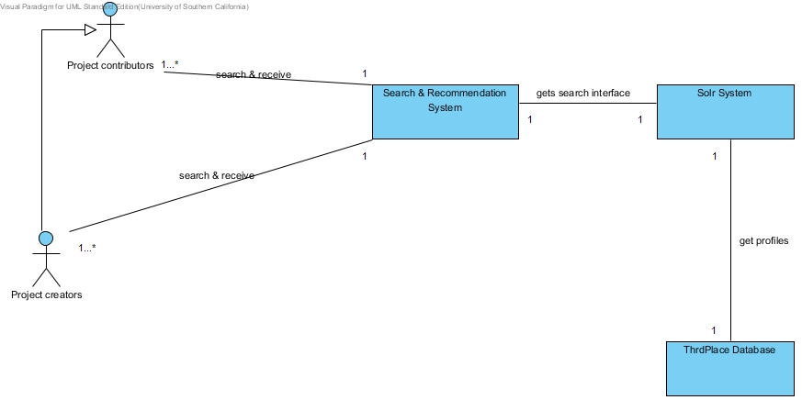
Figure 1: System Context Diagram

Table 1: Actors Summary
Name | Related Use Cases | Documentation
Project creators | receive recommendation of contributors  receive recommendation of projects  view search results by list  search for the most influential projects or contributors  search with filters and get search results | Creators in the system, responsible for creating projects and clarifying required resources in projects, including volunteer hours, money and supplies. They need to login.
Project contributors | receive recommendation of projects  view search results by list  search for the most influential projects or contributors  search with filters and get search results | Contributors in the system, responsible for making contribution to projects, including volunteer hours, money and supplies. They don't need to log in and use their email address as ID.

Artifacts & Information
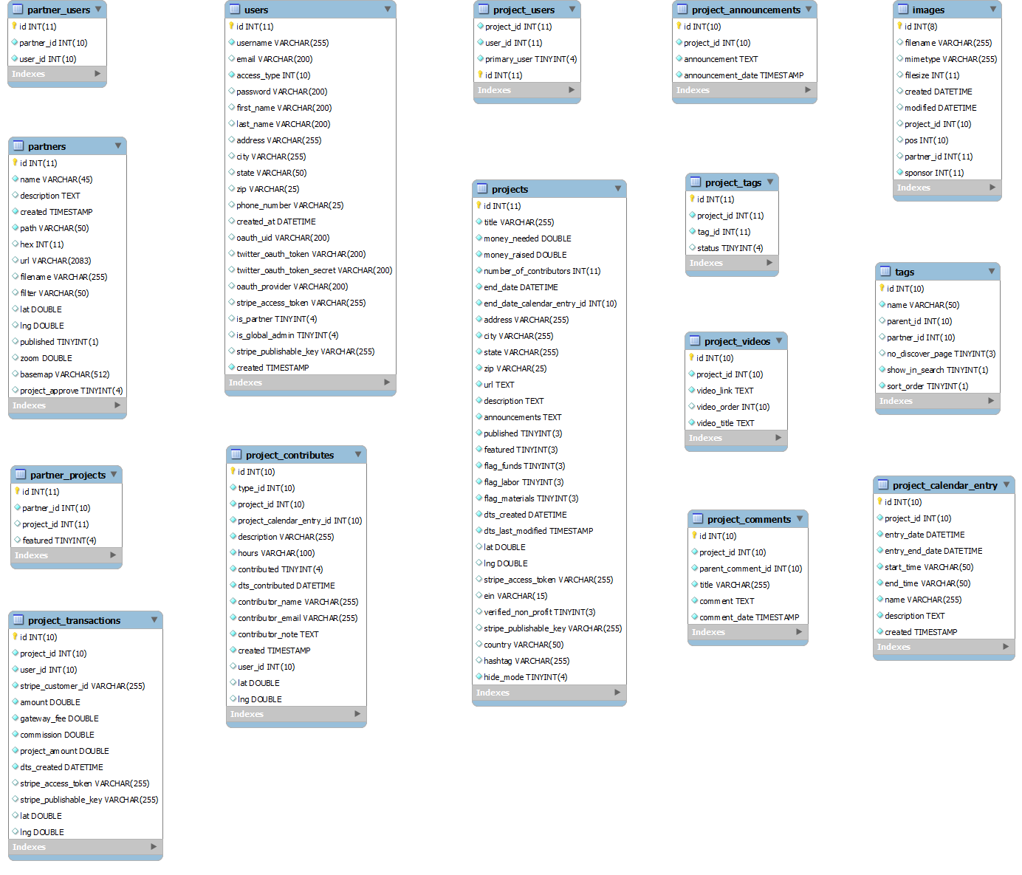
Figure 2: Artifacts and Information Diagram

Table 2: Artifacts and Information Summary
Artifact | Purpose
projects | Contains all information of a project that is necessary for contributors, including name, location information, creator information, resources information, etc.
users | Contains all information of a user, including name, location, contact information, etc.
partner | Contains all information of a partner, including name, email, address, contact information, Facebook likes, etc.
project_contributes | Contains all information required to identify a project contribution process, including project id, contributor id, contribution time, contribution type, etc.
image | Contains all images of a project.
project_comments | Contains all comments of a project.
project_announcements | Contains all announcement of a project.

Behavior
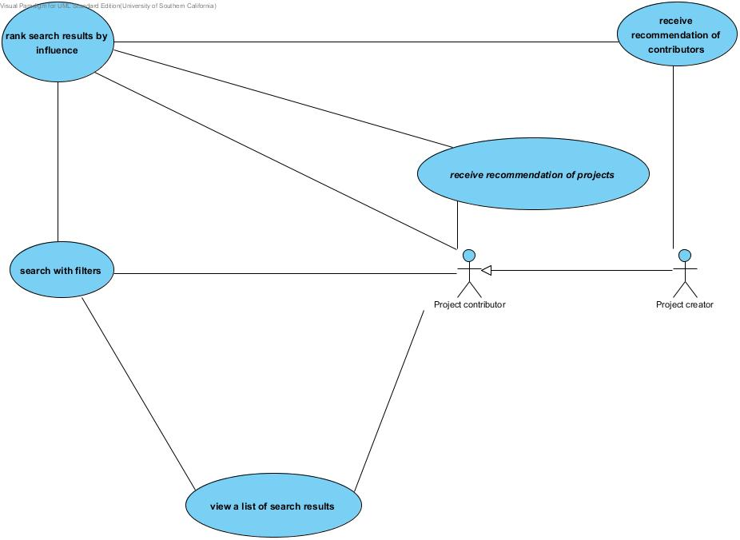
Figure 3: Process Diagram

Search System

Search with Filters
Table 3: Process Description
Identifier | UC02 Search with Filters
Purpose | Contributors / creators can search with filters
Requirements | WC_2442 As a project creator/contributor, I can search for projects and project contributors using filters (state & city).
Development Risks | None
Pre-conditions | Contributors / creators are in search page
Post-conditions | System displays a search result as a list.

Table 4: Typical Course of Action
Seq# | Actor’s Action | System’s Response
1 | On the search page, contributor / creator clicks on the pull-down menu (state or city)
2 |  | System displays a menu with names of states or cities
3 | Contributor / creator clicks on one state or city
4 | Contributor / creator clicks on the category pull-down menu
5 |  | System displays a menu with three category names, project, contributor and creator
6 | Contributor / creator chooses category, types key words (shorter than 32 words) in input box and clicks search
7 |  | System verifies length of key words and finds out that it’s short enough
8 |  | System displays search results that are already filtered
Table 5: Alternate Course of Action
Seq# | Actor’s Action | System’s Response
1 | Contributor / creator clicks on the category pull-down menu
2 |  | System displays a menu with three category names, project, contributor and creator
3 | Contributor / creator chooses category, types key words (shorter than 32 words) in input box and clicks search
4 | Contributor / creator leaves filters empty
5 |  | System verifies length of key words and finds out that it’s short enough
6 |  | System displays search results that are not filtered
Table 6: Exceptional Course of Action
Seq# | Actor’s Action | System’s Response
1 | On the search page, contributor / creator clicks on the pull-down menu (state or city)
2 |  | System displays a menu with names of states or cities
3 | Contributor / creator clicks on one state or city
4 | Contributor / creator clicks on the category pull-down menu
5 |  | System displays a menu with three category names, project, contributor and creator
6 | Contributor / creator chooses category, types key words (longer than 32 words) in input box and clicks search
7 |  | System verifies length of key words and finds out that it’s too long
8 |  | System displays a message that key words are too long

View a List of Search Results
Table 7: Process Description
Identifier | UC06 view a list of search results
Purpose | contributors / creators can view a list of search results
Requirements | WC_2442 As a project creator/contributor, I can search for projects and project contributors using filters (e.g. geolocation, activity etc).  WC_2448 As a project creator/contributor, I can see the search results in a list view
Development Risks | None
Pre-conditions | Contributor / creator is in search page
Post-conditions | System displays search result in a list

Table 8: Typical Course of Action
Seq# | Actor’s Action | System’s Response
1 | Contributor / creator clicks on the category pull-down menu
2 |  | System displays a menu with three category names, project, contributor and creator
3 | Contributor / creator chooses category, types key words (shorter than 32 words) in input box and clicks search, chooses filters or leave them empty
4 |  | System verifies length of key words and finds out that it’s short enough
5 |  | System displays search results in a list view

Ranking System

Rank Search Results by Influence

Table 9: Process Description
Identifier | UC03 rank search results by influence
Purpose | contributors & creators can rank search results by influence
Requirements | WC_2441 As a project creator/contributor, I can search for the most influential projects and project contributors.
Development Risks | None
Pre-conditions | Contributor / creator is in search page
Post-conditions | System sorts search results and displays the most influential projects or contributors at first.

Table 10: Typical Course of Action
Seq# | Actor’s Action | System’s Response
1 | Contributor / creator clicks on the category pull-down menu
2 |  | System displays a menu with three category names, project, contributor and creator
3 | Contributor / creator chooses project types key words (shorter than 32 words) in input box and clicks search, chooses filters or leave them empty
4 |  | System verifies length of key words and finds out that it’s short enough
5 |  | System displays search results in a list view
6 | Contributor / creator clicks Influence in ranking section
7 |  | System ranks projects result and lists the most influential one at first place
Table 11: Alternate Course of Action
Seq# | Actor’s Action | System’s Response
1 | Contributor / creator clicks on the category pull-down menu
2 |  | System displays a menu with three category names, project, contributor and creator
3 | Contributor / creator chooses contributor, types key words (shorter than 32 words) in input box and clicks search, chooses filters or leave them empty
4 |  | System verifies length of key words and finds out that it’s short enough
5 |  | System displays search results in a list view
6 | Contributor / creator clicks Influence in ranking section
7 |  | System ranks contributors result and lists the most influential one at first place

Recommendation System

Receive Recommendation of Projects

Table 12: Process Description
Identifier | UC04 receive recommendation of projects
Purpose | contributors can receive a recommendation with the most influential project
Requirements | WC_2800 As a project creator/contributor, I can see a recommendation section on each page.
Development Risks | None
Pre-conditions | Contributor is in search page
Post-conditions | System displays the most influential project to contributors

Table 13: Typical Course of Action
Seq# | Actor’s Action | System’s Response
1 | Contributor clicks search in home page
2 |  | System jumps to search page and displays the most influential project
Table 14: Alternate Course of Action
Seq# | Actor’s Action | System’s Response
1 | Contributor clicks LOGIN in search page
2 |  | System displays a login window where contributor can type username and password
3 | Contributor types username and password
4 |  | System verifies contributor’s input and authorizes contributor as creator
5 |  | System displays 5 contributors instead of one project
Table 15: Exceptional Course of Action
Seq# | Actor’s Action | System’s Response
1 | Contributor clicks LOGIN in search page
2 |  | System displays a login window where contributor can type username and password
3 | Contributor types username and password
4 |  | System verifies contributor’s input and authorization fails; system displays a message saying that username or password is wrong

Receive Recommendation of Contributors

Table 16: Process Description
Identifier | UC05 receive recommendation of contributors
Purpose | creators can receive a recommendation with 5 most influential contributors
Requirements | WC_2800 As a project creator/contributor, I can see a recommendation section on each page.
Development Risks | None
Pre-conditions | Creator is in search page
Post-conditions | System displays 5 contributors that may be interested in creator’s most recent project

Table 17: Typical Course of Action
Seq# | Actor’s Action | System’s Response
1 | Creator clicks search in home page
2 |  | System jumps to search page and displays 5 contributors that may be interested in creator’s most recent project
Table 18: Alternate Course of Action
Seq# | Actor’s Action | System’s Response
1 | Contributor clicks LOGOUT in search page
2 |  | System displays the most influential project instead of 5 contributors

Modes of Operation
ThrdPlace system, as well as our sub-system that deals with search & recommendation, only operates in one mode. So there is no additional information concerning modes of operations provided.

System Analysis Rationale
There are typically two kinds of users, contributors and creators.
Contributors: A contributor can contribute to one or more projects. Their contribution can be in three types, volunteer hours, money and supplies. They don’t receive reward and only contribute. Contributors don’t login, they leave their emails to creators as their identities. However, they have profiles recorded in database.
Creators: A creator can create one or more projects and collect resources needed for their projects from contributors. Creators need to login to manage their projects.
There are two external interfaces, ThrdPlace database and Solr.
ThrdPlace database: The ER diagram of ThrdPlace database is shown in figure 2.
Apache Solr: We use Solr as full-text search engine, and implements filters through Solr’s filter query.

Technology-Independent Model
This document has no technology-independent model because our system is a subsystem of ThrdPlace website. In this way, many technologies, such as developing language, web server, database manager, have already been chosen by our clients. Therefore, our subsystem needs to be shaped around it.

Technology-Specific System Design

Design Overview

System Structure
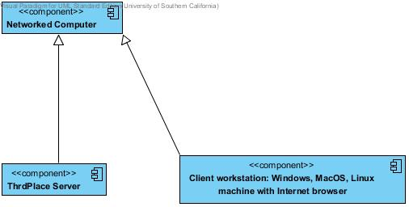
Figure 4: Hardware Component Class Diagram

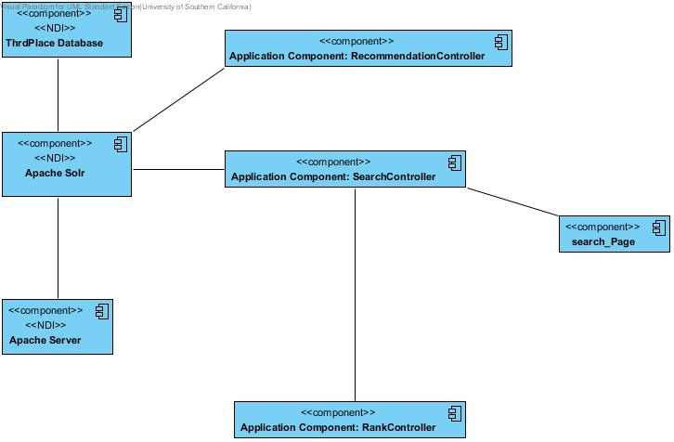
Figure 5: Software Component Class Diagram

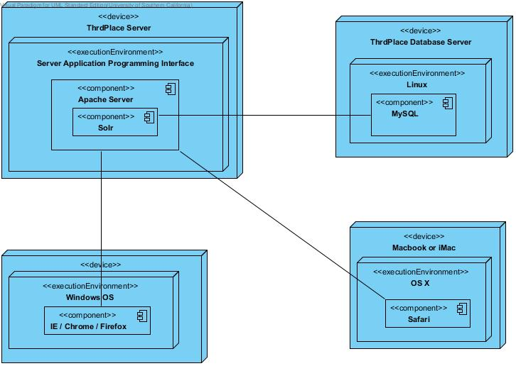
Figure 6: Deployment Diagram
Table 19: Hardware Component Description
Hardware Component | Description
PC | A networked computer running Windows OS.
iMac or MacBook | A networked computer running Mac OS.
Networked Computer | A computer that is connected to other networked computers through the internet.
ThrdPlace Server | A server where ThrdPlace website runs.
ThrdPlace Database Server | A server where database of ThrdPlace runs.

Table 20: Software Component Description
Software Component | Description
Application Component: search manager | A search engine applying Solr service.
Application Component: rank manager | A ranking manager that sorts results according to influence
Application Component: recommendation manager | A recommendation manager that returns the most influential project to contributors. And finds contributors that may be interested in creator’s most recent project, then returns the result to creators.
Application Component: filter manager | Provides filter words to filter search results.
Apache Server | A server software.
User Interface | UI of our system, i.e. search page
Search section | Search UI, including an input box, a pull-down menu regarding category, a search button and a results display section
Rank section | Ranking part, including several words.
Recommendation section | Recommendation UI that displays one project or 5 contributors.
Filter section | Includes two pull-down menu that lists state names and city names
ThrdPlace Database | ThrdPlace’s database, which contains tables of system.
Apache Solr | Solr search service.

Design Classes

Interface Classes
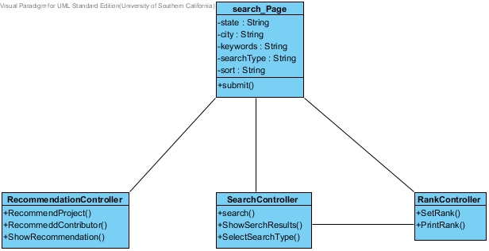
Figure 7: Design Class Diagram
Table 21: Design Class Description
Class | Type | Description
search_Page | Boundary | The only page of searching system. Records attributes necessary to perform searching and can submit these attributes.
RankController | Controller | A ranking manager that can rank results according to ranking words.
SearchController | Controller | A search engine using Solr service.
RecommendationController | Controller | A recommendation manager that returns projects to contributors, or contributors to creators.

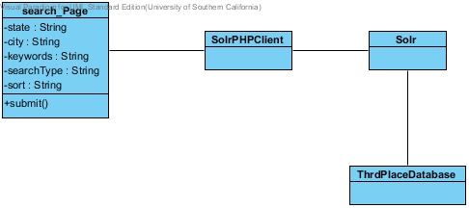
Figure 8: Search with Filters Class Diagram

Process Realization
The process realization part shows sequence diagrams of the most two risky use cases. In our sub-system, search (by filters) is the riskiest use case, and receive recommendation of contributors is the second, because search engine is the core part of our sub-system. Without search engine, all other components (including recommendation & ranking) won’t work at all.

Search with Filters
This is the riskiest use case in our system because all other use cases rely on a correctly implemented search engine.

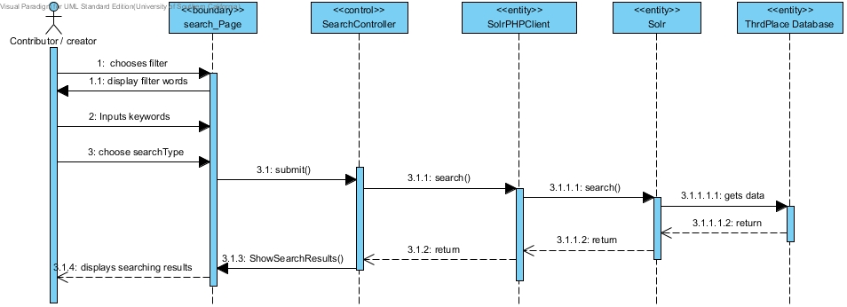
Figure 9: Search with Filters Sequence Diagram

Receive Recommendation of Contributors
This is also a risk use case, as emphasized by our clients. Creators need to login here, and login function has been implemented by ThrdPlace.
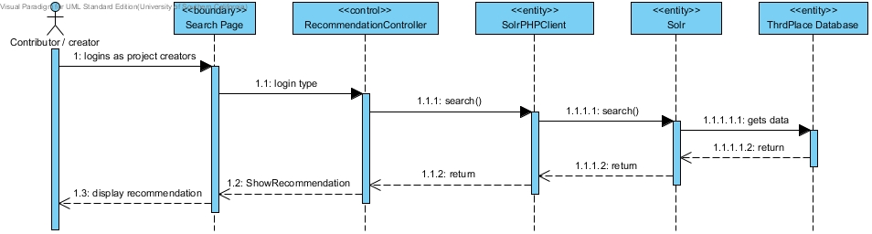
Figure 10: Receive Recommendation of Contributors Sequence Diagram

Design Rationale
Our system’s most high-risk requirement is search, then recommendation and then ranking. After our analysis of ThrdPlace system, our solution to develop these three sub-systems is as following:
1. As contributors are not required to login, thus they receive the same recommendation. In this case, we only recommend the most influential project to them.
2. As creators need to login, we can recommend specific contributors to specific creators. Also, as one creator is only interested in his current project, we use his most recent project’s name as key words to search for contributors, and then recommend relevant contributors to them.
3. Ranking can be implemented by a simple sort function.
Our system architecture is client/server, as shown in deployment & hardware diagrams
The user interfaces are divided into 3 sections: search, rank and recommendation. Search section has one input box, one category button, one search button and two filters. Rank part has several key values as ranking conditions. Recommendation part only displays recommended projects or contributors.

NDI Components

Chosen NDI Components
Table 22: NDI Components
Software Component | Description | Purpose
WAMP | Software bundles | Provide support for convenient and quick web development on windows platform.
MySQL | Relational database  management system | Store project, creator and contributor’s information on ThrdPlace
IE, Chrome, Safari | Web browser | Web front end for users of ThrdPlace
PHP | Server-side script language | Provide support for implementing functions on the server.
Solr | Search engine | Provide full-text search with filter and sort functionality

NDI Components That Were Not Chosen

Sphinx
There’re two NDI/NCS that are recommended by our clients to serve as search engine, Solr and Sphinx. Based on system requirements and specific features, we made a list of criteria to evaluate the two NDI/NCS candidates. Then after discussing with our clients, we gave weights to each of the attributes and features and got an evaluation matrix, which is provided in FED.
Generally speaking,
- Solr performs much better than Sphinx in ease of use.
- Solr has better HTML administration interface than Sphinx.
Based on the results of evaluation, Solr is highly recommended as the search engine in our project rather than Sphinx.

Architectural Styles, Patterns and Frameworks
Table 23: Architectural Styles, Patterns, and Frameworks
Name | Description | Benefits, Costs, and Limitations
Client – server architecture | Client – Server architecture is an approach to computer network programming in which computers in a network assume one of two roles: server and client. The server selectively shares its resources, and the client initiates contact with a server in order to use those resources. | Benefits:  - Centralization – access, resources, and data security are controlled through the server  - Scalability – any element can be upgraded when needed  - Flexibility – new technology can be easily integrated into the system  - Interoperability – all components (clients, network, servers) work together  Costs:  - There is no specific cost of client – server architecture  Limitations  - Because the server can perform a limited number of tasks at any moment, it relies on a scheduling system to prioritize incoming requests from clients in order to accommodate them all in turn  - The server's software limits how a client can use the server's resources

